 Mrs. Stephanie & Mrs. Elisa’s Newsletter
March 24, 2023
Next week it’s all about Easter! The class will decorate their bags for the hunt, paint cardboard eggs, and make an Easter craft. Please don’t forget the pre-filled eggs and any treat you want to send in. Again, our hunt is Friday around 12:15. Let me know if you want to help.
Mark your calendars

March 30th – Dairy Queen night

April 3rd – 7th – Spring Break

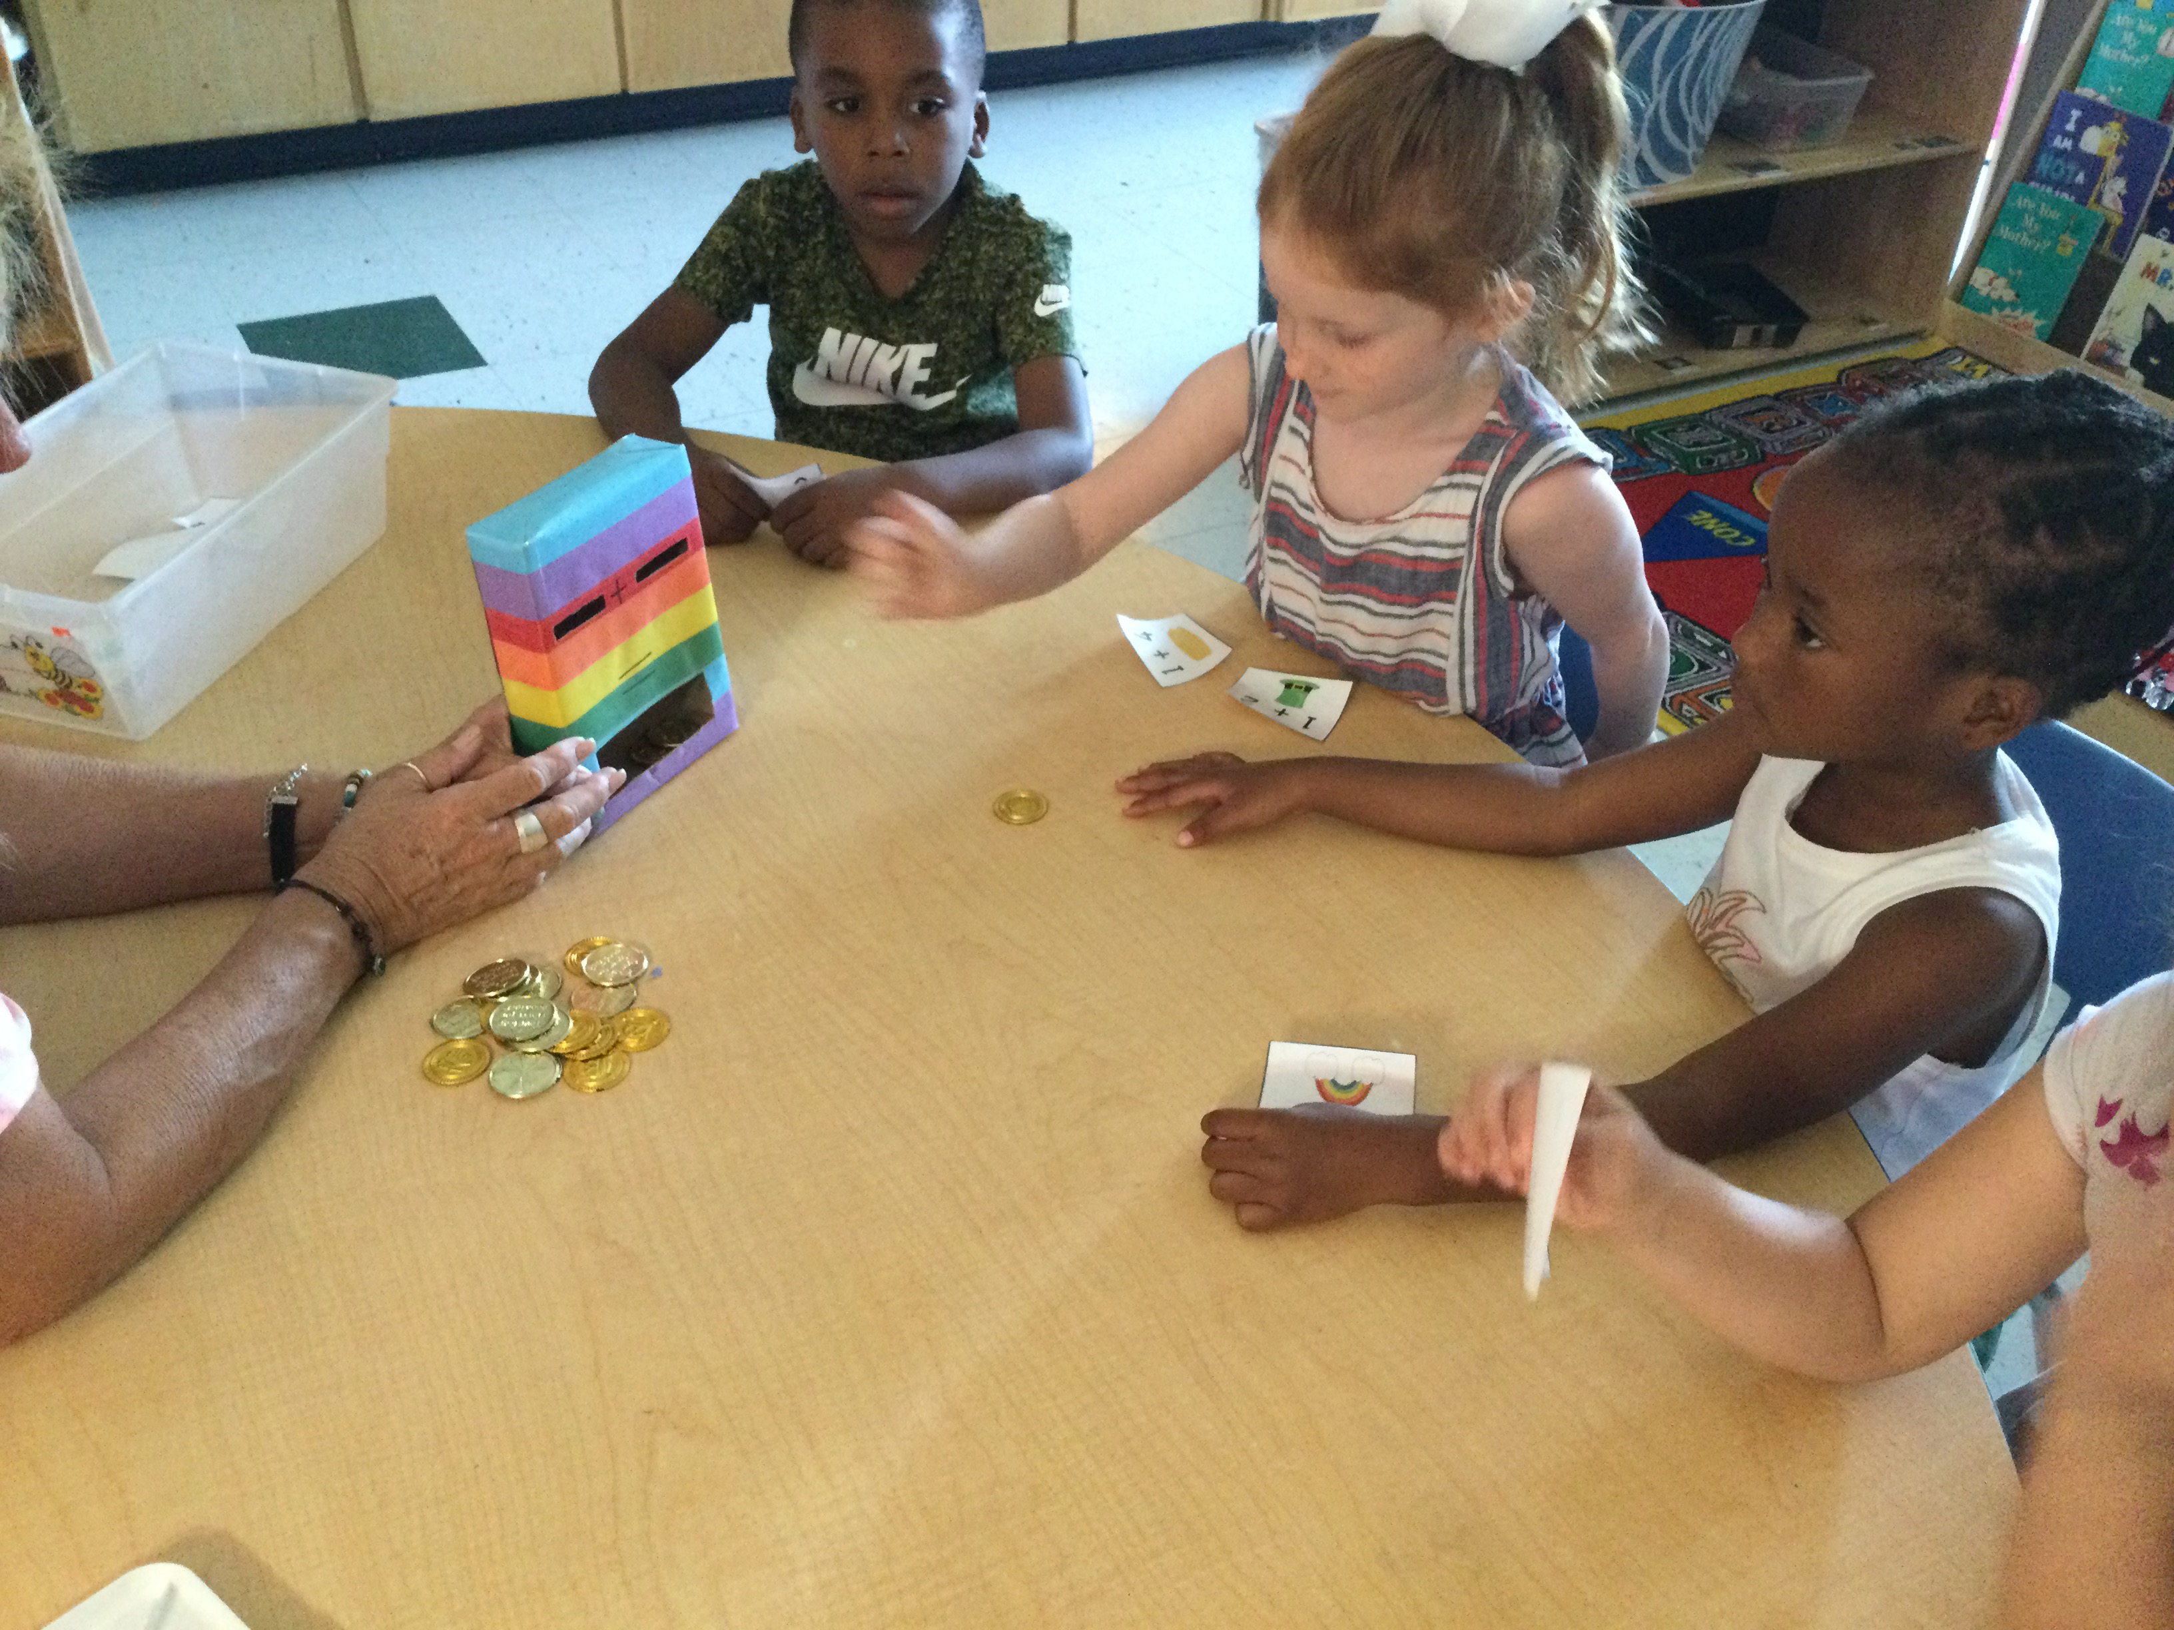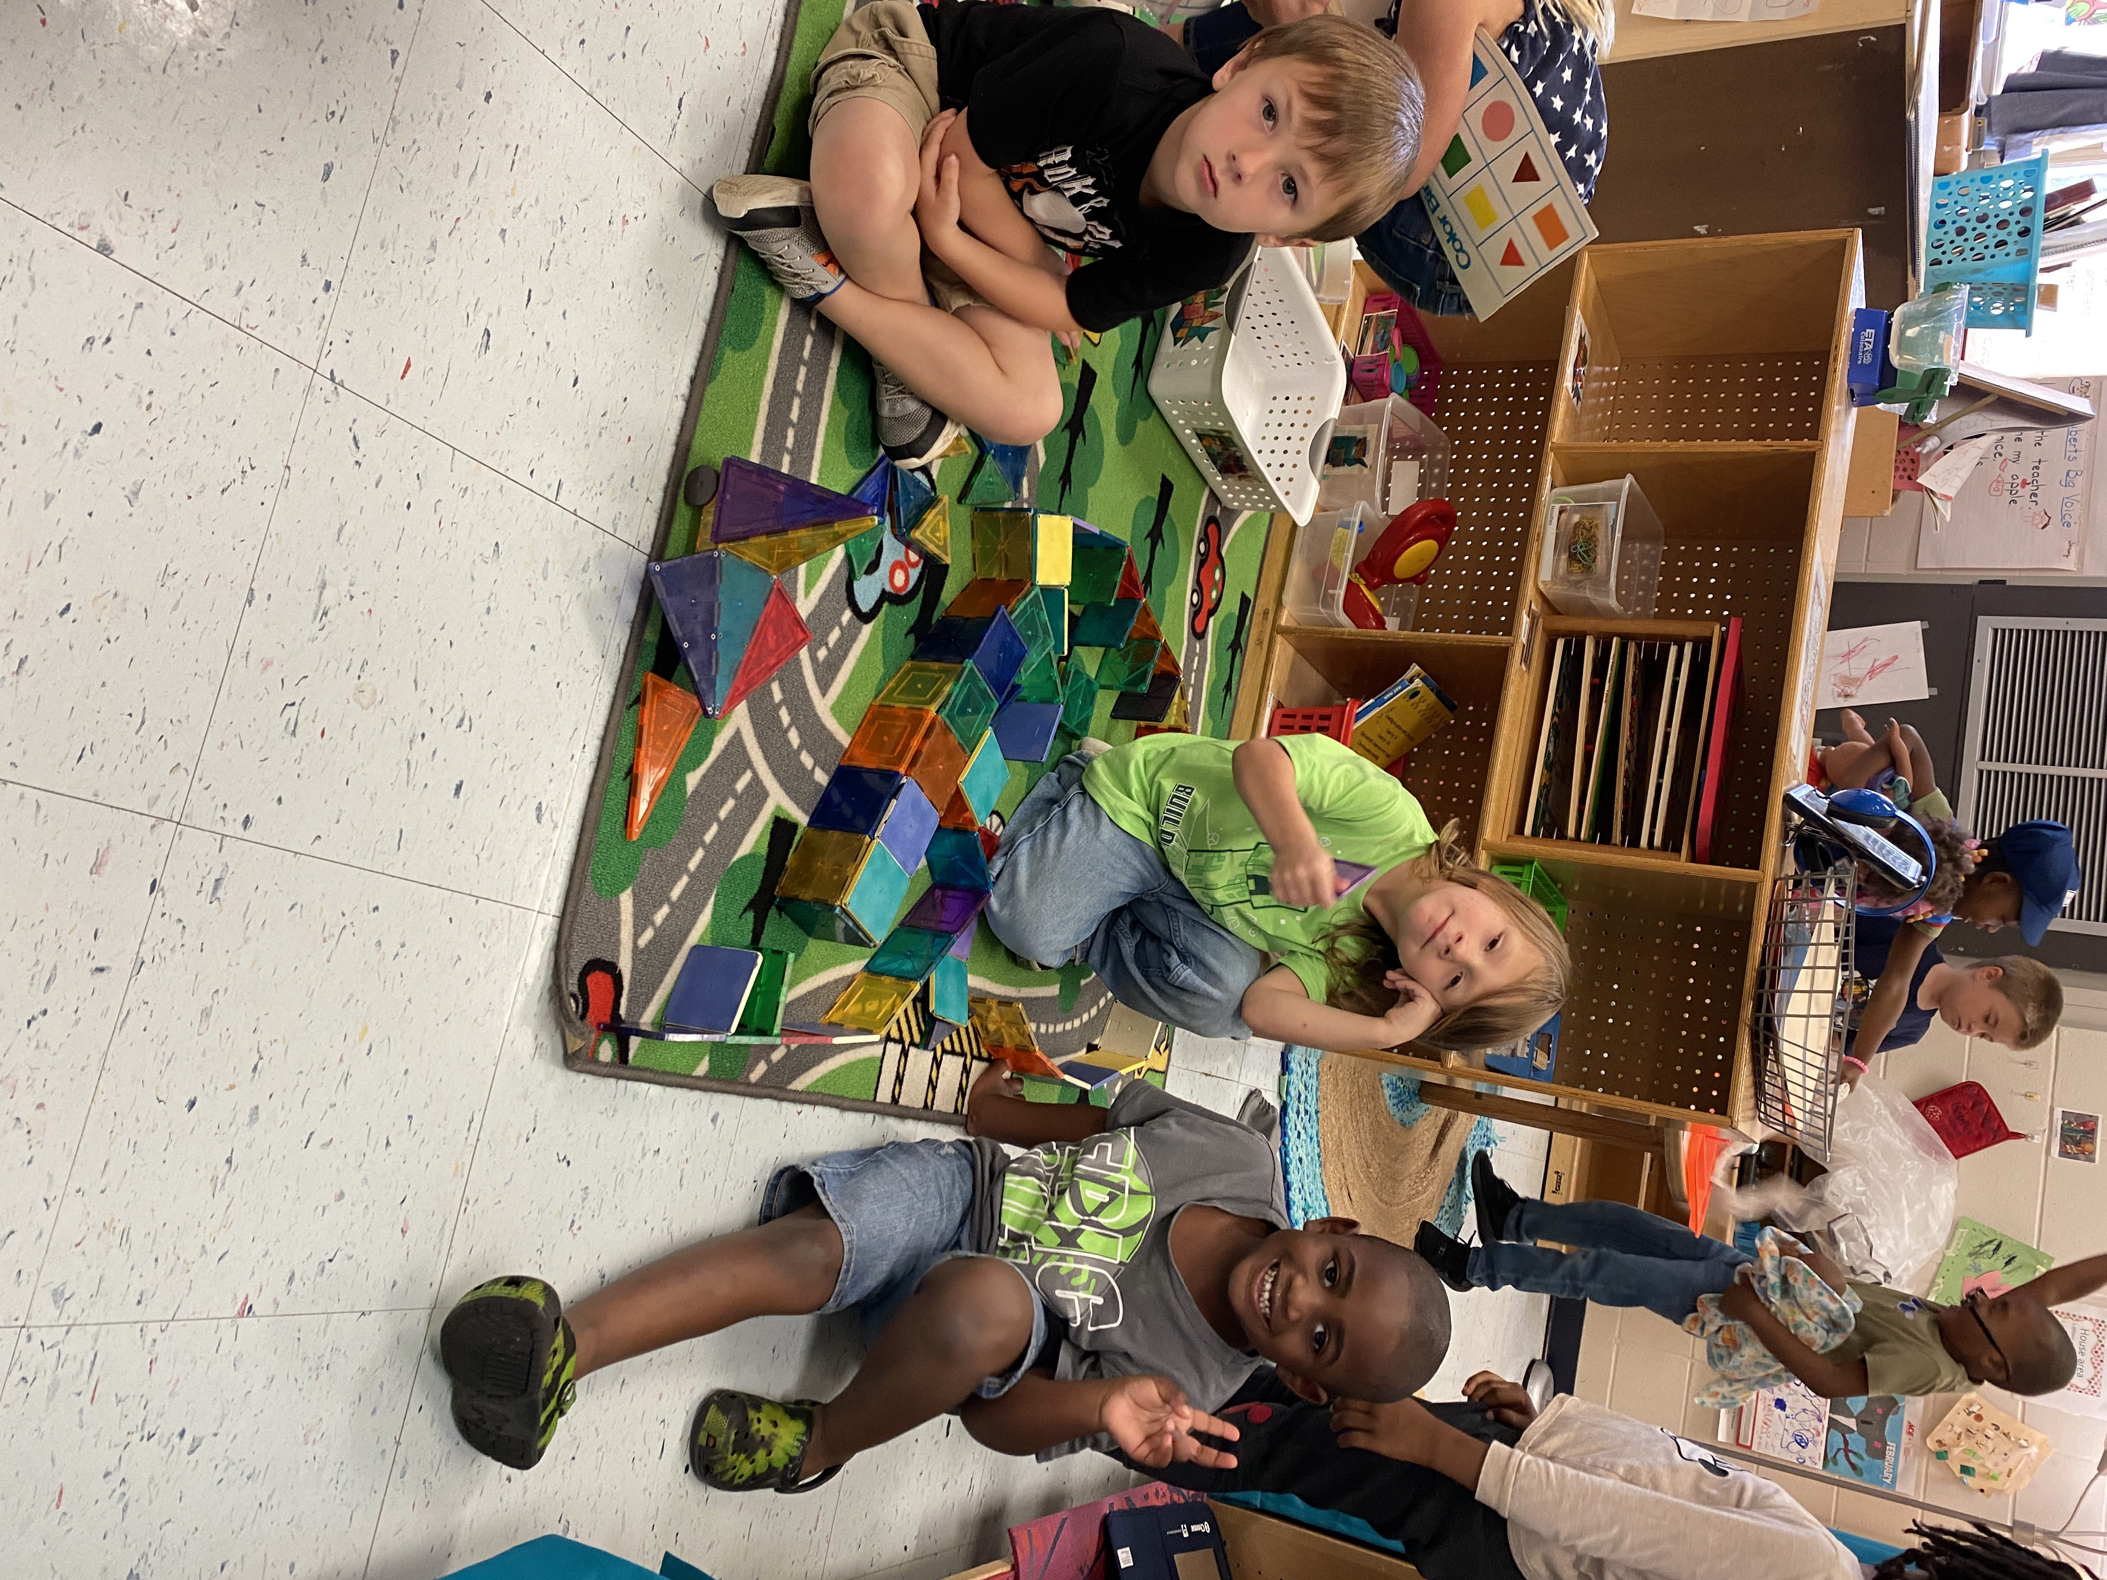

Gold coin addition. Using magna tiles to make unique structures.

Contact me at: sconnally@tcjackets.net or Seesaw or 225-3908

